**INTERACTIVE DATA VISUALIZATION ON GLOBAL TERRORISM USING PYTHON AND BOKEH**

**STUDENT NAME: Ashish C Bharadwaj**

**STUDENT ID: 10396445**

**TEAM MATES**

**1.Swapnil Chaudhari -10505342**

**2.Rakesh Pattanad - 10390582**

**MODULE: DATA VISUALIZATION**

**LECTURAR : BASEL MAGABLEH**

**TOOL FOR VISUALIZATION: PYTHON , JUPYTER**

**DUBLIN BUSINESS SCHOOL**

**Dataset: Global Terrorism Database**

**More than 180,000 terrorist attacks worldwide, 1970-2017**

The Global Terrorism Database (GTD) is an open-source database including information on terrorist attacks around the world from 1970 through 2017. The GTD includes systematic data on domestic as well as international terrorist incidents that have occurred during this time period and now includes more than 180,000 attacks. The database is maintained by researchers at the National Consortium for the Study of Terrorism and Responses to Terrorism (START), headquartered at the University of Maryland.

This dataset contains 100 variables on location, tactics, perpetrators, targets, and outcomes

records of 180,000 records . Data can be found on <https://www.kaggle.com/START-UMD/gtd>

**Github Repository :** <https://github.com/10396445/Global-Terrorisms-Database>

**Data fields**

Here's a brief version of what you'll find in the data description file.

**Columns**

* Eventid -A 12-digit Event ID system. First 8 numbers – date recorded “yyyymmdd”. Last 4 numbers – sequential case number for the given day (0001, 0002 etc).
* iyear- This field contains the year in which the incident occurred.
* Imonth- This field contains the number of the month in which the incident occurred.
* Iday -This field contains the numeric day of the month on which the incident occurred.
* approxdate
* extended1 = "Yes" The duration of an incident extended more than 24 hours. 0 = "No" The duration of an incident extended less than 24 hours.
* resolution
* country -This field identifies the country code
* country_-txtThis field identifies the country or location where the incident occurred.
* Region-This field identifies the region code based on 12 regions
* region_ -txtThis field identifies the region in which the incident occurred.
* provstateName -(at the time of event) of the 1st order subnational administrative region
* cityName -of the city, village, or town in which the incident occurred
* latitude-The latitude of the city in which the event occurred.
* Longitude-The longitude of the city in which the event occurred.
* specificity
* vicinity
* location
* summary
* crit1
* crit2
* crit3
* doubtterr
* alternative
* alternative_txt
* multiple
* success-Success of a terrorist strike
* suicide1 = "Yes" The incident was a suicide attack. 0 = "No" There is no indication that the incident was a suicide attack.
* attacktype1-The general method of attack
* attacktype1_-txtThe general method of attack and broad class of tactics used.
* attacktype2
* attacktype2_txt
* attacktype3
* attacktype3_txt
* targtype1
* targtype1_-txtThe general type of target/victim
* targsubtype1
* targsubtype1_-txtThe more specific target category
* corp1
* target1-The specific person, building, installation that was targeted and/or victimized
* natlty1
* natlty1_txt-The nationality of the target that was attacked
* targtype2-
* targtype2_txt-
* targsubtype2
* targsubtype2_txt
* corp2
* target2
* natlty2
* natlty2_txt
* targtype3
* targtype3_txt
* targsubtype3
* targsubtype3_txt
* corp3
* target3
* natlty3
* natlty3_txt
* gname-The name of the group that carried out the attack
* gsubnameadditional- details about group that carried out the attack like factions
* gname2
* gsubname2
* gname3
* gsubname3
* motive
* guncertain1
* guncertain2
* guncertain3
* individual
* nperps-The total number of terrorists participating in the incident
* nperpcap
* claimed
* claimmode
* claimmode_txt
* claim2
* claimmode2
* claimmode2_txt
* claim3
* claimmode3
* claimmode3_txt
* compclaim
* weaptype1
* weaptype1_txt-General type of weapon used in the incident
* weapsubtype1
* weapsubtype1_txt-More specific value for most of the Weapon Types
* weaptype2
* weaptype2_txt
* weapsubtype2
* weapsubtype2_txt
* weaptype3
* weaptype3_txt
* weapsubtype3
* weapsubtype3_txt
* weaptype4
* weaptype4_txt
* weapsubtype4
* weapsubtype4_txt
* weapdetail
* nkill-The number of total confirmed fatalities for the incident
* nkillus-The number of U.S. citizens who died as a result of the incident
* nkillter
* nwound-Number of confirmed non-fatal injuries to both perpetrators and victims.
* Nwoundus-The number of confirmed non-fatal injuries to U.S. citizens, both perpetrators and victims.
* nwoundte
* property
* propextent
* propextent_txt
* propvalue
* propcomment
* ishostkid
* nhostkid
* nhostkidus
* nhours
* ndays
* divert
* kidhijcountry
* ransom
* ransomamt
* ransomamtus
* ransompaid
* ransompaidus
* ransomnote
* hostkidoutcome
* hostkidoutcome_txt
* nreleased
* addnotes
* scite1
* scite2
* scite3
* dbsource
* INT_LOG
* INT_IDEO
* INT_MISC
* INT_ANY
* Related

**Initial Analysis Questions**

* 1. **How many distinct regions exist in the dataset? What are the regions containing the highest and the lowest casualties?.Compare casualties, death toll and counts wounded in each region.**
  2. **Compare the terror attack trend in each regions.**
  3. **Use the geographic information from the dataset to create a map. And visualize the top countries affected by the terror attacks. Identify the top 5 countries with the highest casualties . And also mention countries with the least casualties and terror attacks?**
  4. **Highlite the most frequent attacked cities on map.**
  5. **Which are the 5 years with the highest terror attacks? What are the total casualties in the same years?**
  6. **What are the top 20 active terror groups ?**
  7. **Discuss the counts of terror attack by its type.**
  8. **What kinds of weapons are used in terror attacks?**
  9. **What is the most common motive behind the terror attacks?**

Discoveries and Insights

**Q1**

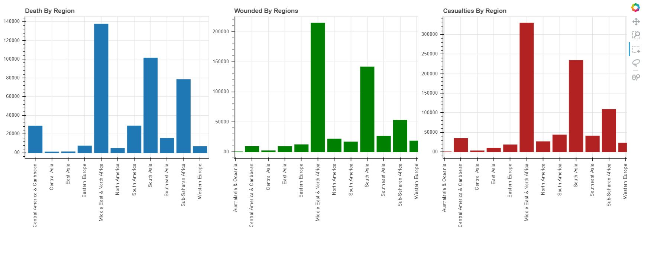

We have the information on the deaths, wounds and casualties caused by the attack of terrorists on particular region. We have tried visualizing the same using the bar graph which gives the counts of death (Shown in Blue), count of wounded (shown in Green) and the count of the casualties (Shown in Red) caused by the attack of terrorists depending upon the region. The 1st Bar graph illustrates the number of deaths caused by the terrorist attacks. Middle East and North Africa has the highest number of deaths caused by the terrorist attack close to 140000 deaths from 1970 through 2017

The 2nd bar graph illustrates the number of wounds caused due to terrorists attack. The graph shows Australia and Oceania has least number wounds of about less than 1000 where the Middle East region and North African region has the highest number with more than 240000. The 3rd graph illustrates the casualties caused by the terrorist attack. The graph shows Australia and Oceania has least number of casualties caused with less than 100 whereas Middle East region and North African region has the highest count with more than 350000 casualties caused.

From the bar graph, we can confirm that the in Middle East and North Africa counts of death ,wounded and casualties all are the highest. Interestingly, Central Asia , East Asia and Australia & Oceania have almost 0 or below 100 casualties. In other words, seems like nations in these regions like Australia and Israel have the most active counter-terror units to protect their citizens.

**Q2.**

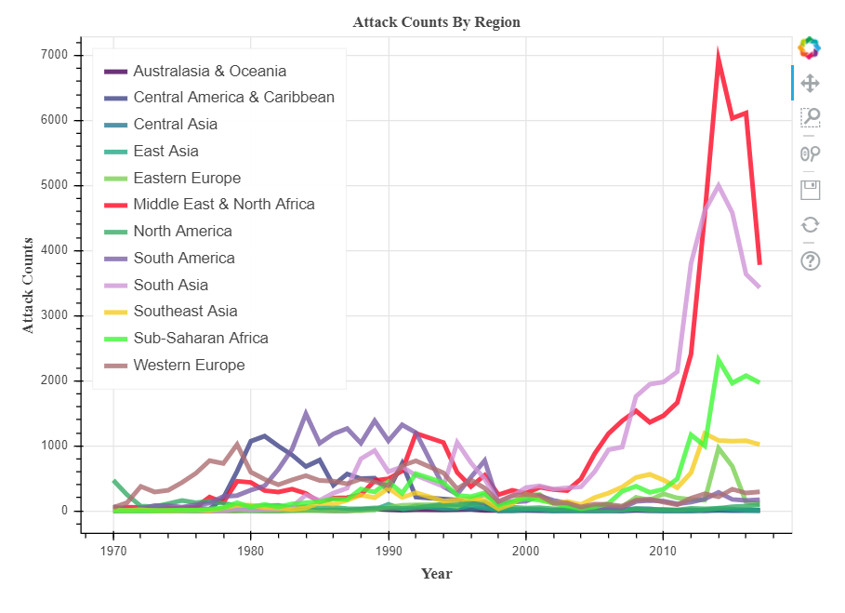

From , above graph , it is clear that terror activities East Asia, Central Asia, Australia & Ocenia remain almost negligible throughout the time period (1970 – 2017). In remaining regions, it remained at average 0f 50 from 1970 to 2000. We have tried to visualize the attack counts on different regions from 1970 through 2017. Plotted time (years) versus the attack counts per region. We have provided different colours for different region to differentiate. We can see that the terrorist attacks during 1970s to 1980s were very minimal and has drastically increased over time in every region except for few. We can observe that during the time from 2000 till 2017, the Middle East, North African and South Asian region has suffered with more number of attacks than any other region with dramatical increase of attacks over time, for more than 7000 and 5000 attacks correspondingly during 2010 and 2012. Interestingly, Central Asia , East Asia and Australia & Oceania have almost 0 or below 100 casualties. In other words, seems like nations in these regions like Australia and Israel have the most active counter-terror units to protect their citizens. However, sudden hike is observed in the duration of 2000 to 2017. What should be the reason behind it? Especially, in Middle East - North Africa and South Asia terror activities have drastically increased.

Q3. Interactive Choropleth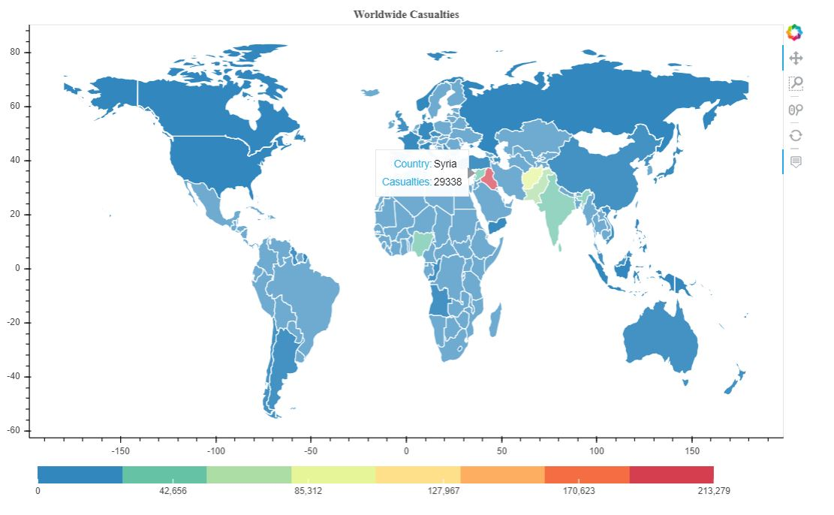

The interactive choropleth map above shows the worldwide casualties. Each country is colored according to the shade the casualties counts in terror attacks. The color palette below shows the casualties with respect to color. As we can see Iraq holds the rightmost color of the palette , hence with the highest casualties (213279 casualties ). That is followed by Afghanistan(>85000), Pakistan (>65000)and India(>48000). These countries have the highest casualties in terror attacks in the history. Countries with blue colors like Australia (136 only), Brazil (363),Jordan(393), Canada(511) have the lowest casualties in terror attacks.

After allocating attack target coordinates, We can clearly see dominance of terror activity in Syria, Pakistan, Afghanistan and North-East India. China, Australia, Canada, Russia are still not in effect of terrorism.

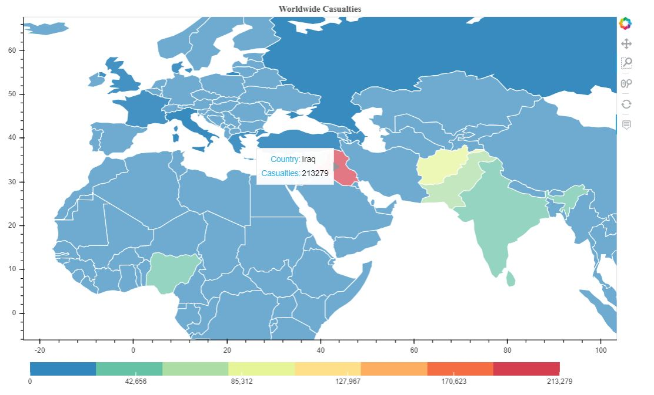

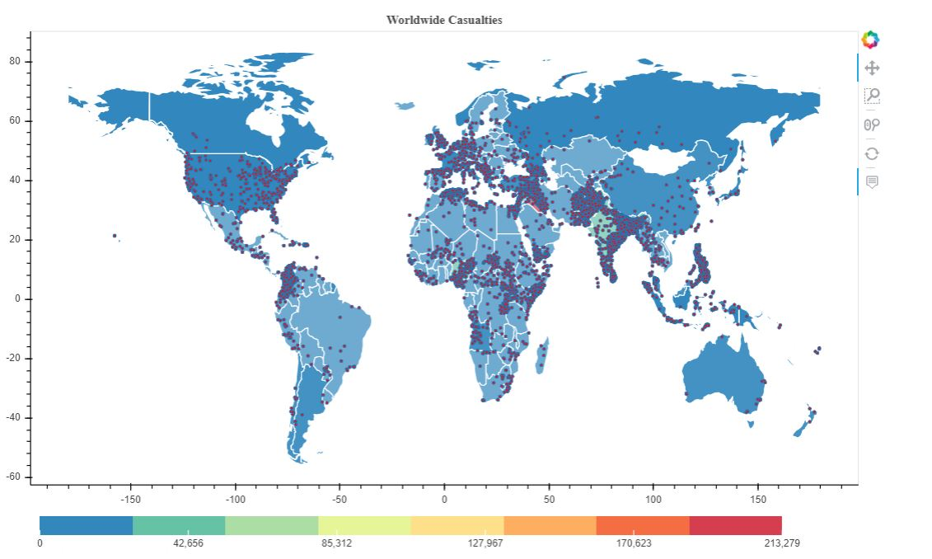

Zoom in effect

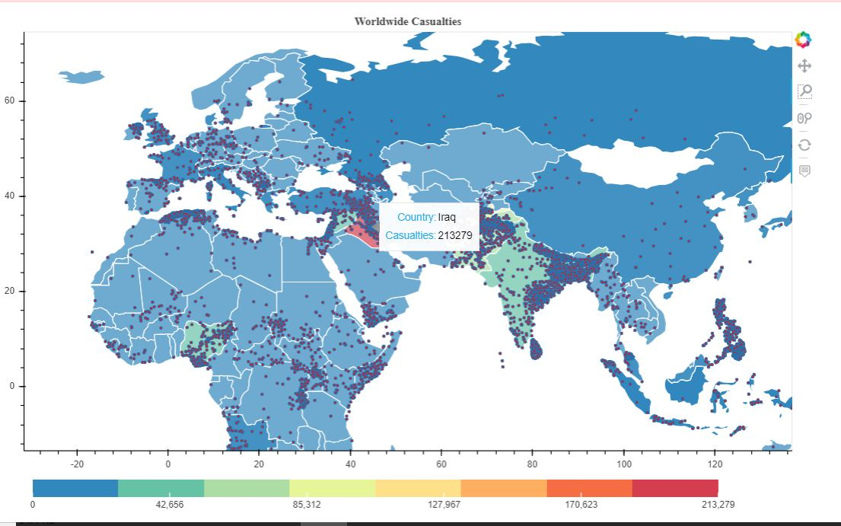

**Q4.**

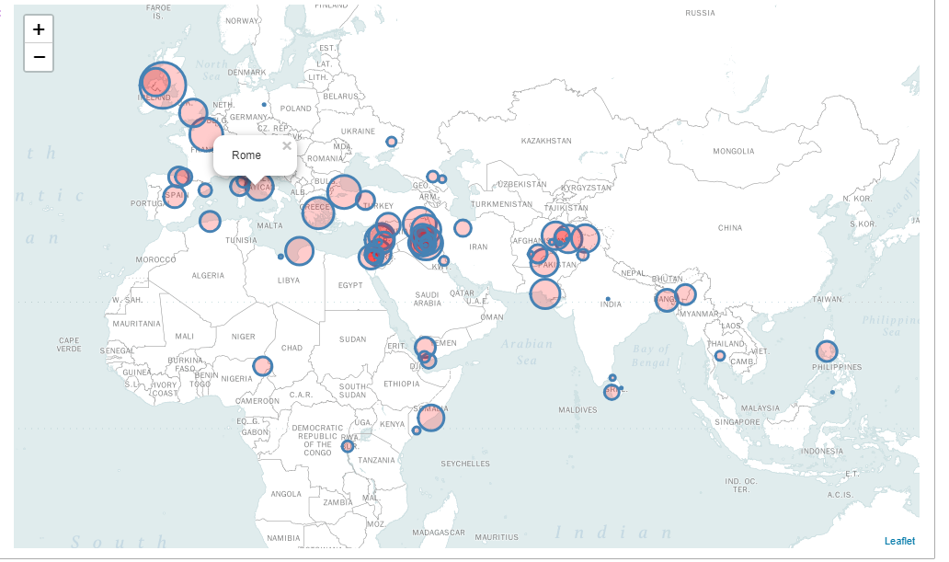

The graph highlights top 100 targeted cities in the history of terror attacks. We can confirm from this graph that Middle East countries like Iraq, Syria, and some Asian countries Pakistan, Afghanistan are frequently targeted countries. In other words, hot target of terror groups.

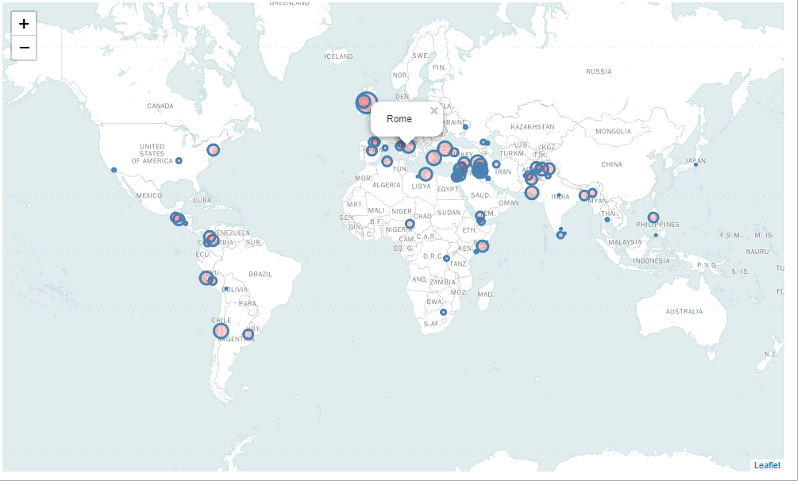

**Q5.**

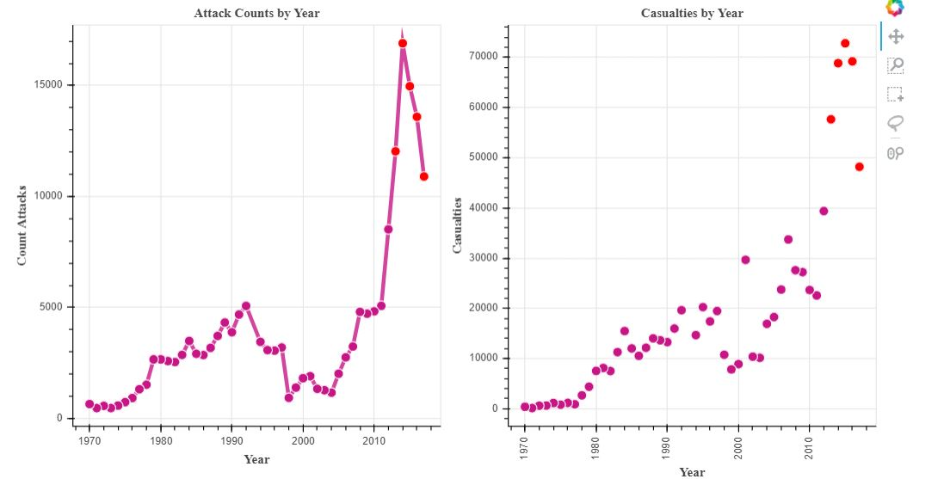

The line graph articulates the attack counts by year and scatter plot represents the casualties by year. We can observe the rise in terror activity with the time in 20th century. Attacks were highest in 2014 (16903attacks and more than 68000 casualties).2012, 2013,2014,2015,2016,2017 holds the highest terror attacks across the globe, This points are red colored in the graph. If we deep dive further, the period between 2000-2005, there were fewer attacks but higher causalities. If we compare line graph and scatter plots, the data is showing similar trends in terms of attacks and causalities except the duration of 2000-2005, this might be an influence of 9/11 attacks in the US which had higher causalities. the graph.

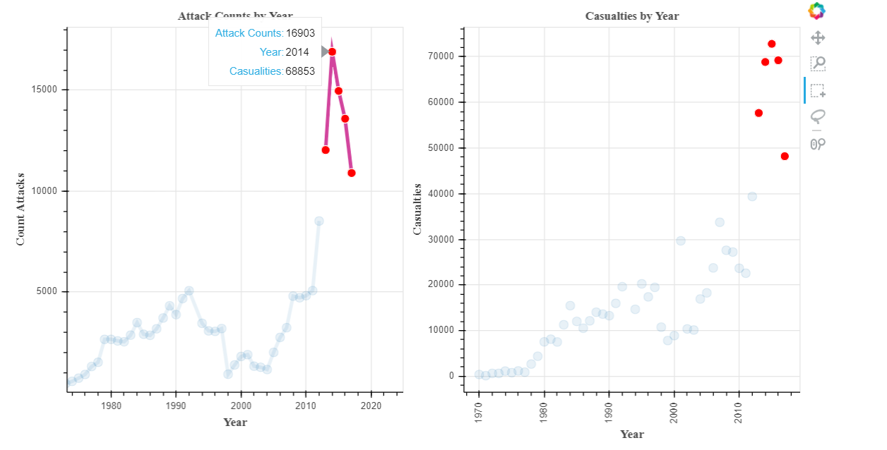

Q6.

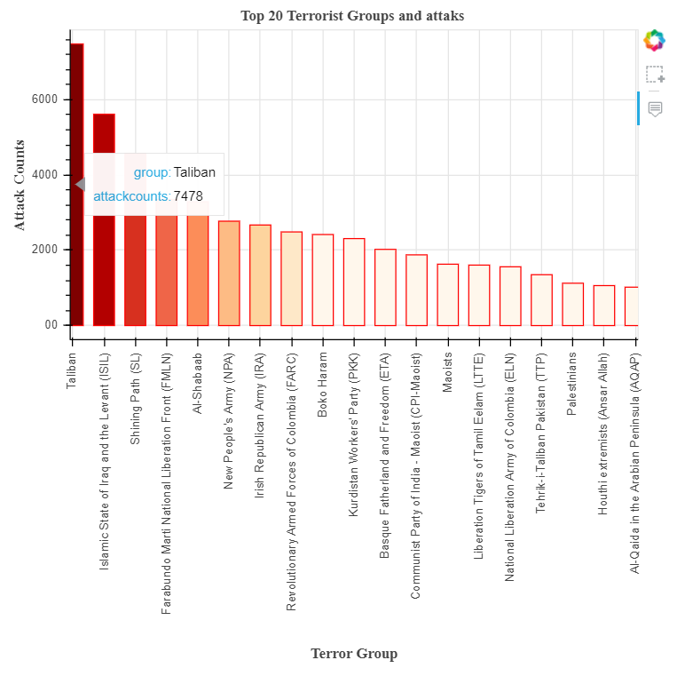

The Bar Graph above visualizes the terrorist attacks by different terrorist organizations. We have plotted the graph with the terrorist organization versus their attack counts .The intensity of the colour in the bar depends upon the number of attacks, The darker the color, the higher the attacks counts of the group. Taliban group has toppled all other groups . According to data Taliban (Afghanistan) is the most active group in the world with 7478 attacks till 2017. It is followed by ISIL(middle east, 5613 attacks) at second rank. Shining path (4555 attacks) at 3rd rank, FMLN(3351 attacks) 4th, Al Shabab (3288 attacks) 5th then NPA(2772 attacks) and Irish Republican Army-2671 attacks (active in Ireland, Europe) at 6th Rank.

**Q7.**

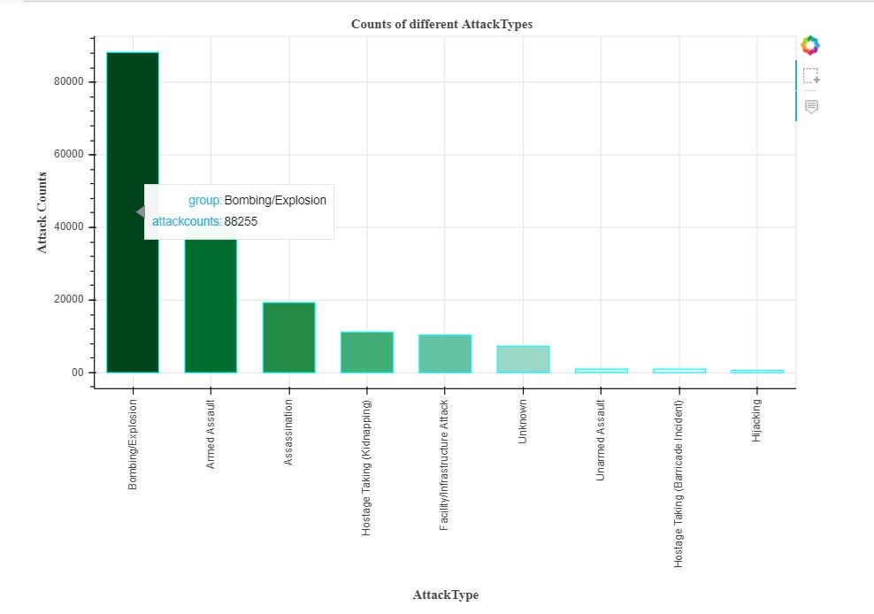

This illustration gives information about the types of attack carried out by the terrorists. The below graph shows that the terrorists has used explosives and bombs to explode the places mostly when compared to other types and hijacking is the least type as shown. The most prevalent type of attacks in all attacks are bombing/ explosion. According to data, so far more than 90 thousand bomb attacks are observed. Armed assault stands at 2nd rank with 42669 records. Assassination carried out by terror groups counts for 19312 records. Hostage taking, Facility attack , unnamed assult, hostage taking (barricade) , hijacking are other kind of terror styles. However, attacks types of 7276 records are still unknown.

Q8.

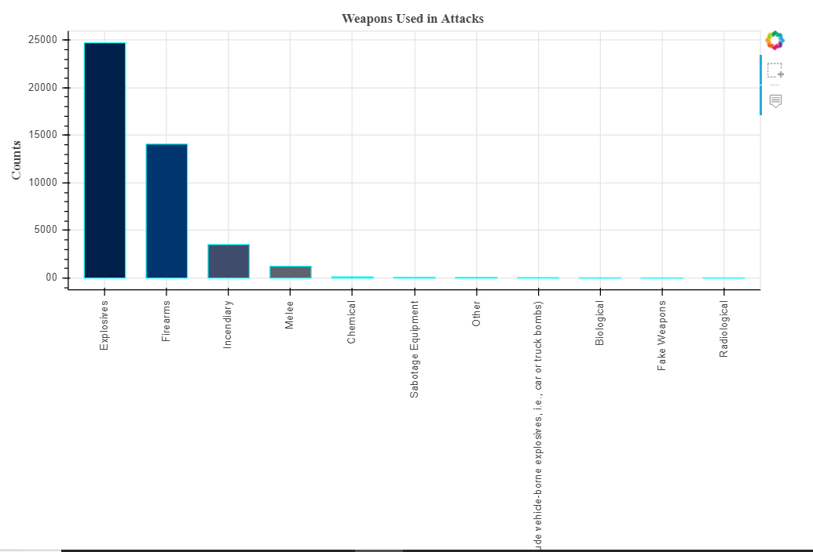

We can observe the dominance of explosives in terror attacks from above graph. In other words it is very disappointing to say that most of the lives lost or damages , harm is done by means of explosives. It holds 24,713 records, Firearms stand at the second rank with 14077 records and Incendiary at third with 3520 records. Other weapons like chemical , biological detrimental weapons are less used (<150 records). The radiological weapons are the least used weapon for the attack made by the terrorists. The next mostly used weapons are firearms and incendiary weapons. By this we can say that the attacks might be performed easily with explosives and firearms than any other weapons and that might be the reason why the terrorists would usually prefer explosives and firearms over other weapons to perform the attack and also we can assume that the explosives and the firearms might be available and can get it easily when compared to other weapons.

**Q9.**

Using the word cloud visualization on the textual data we can detect most frequent words. As we can see violence is the the largest word. It means violence is the most frequent word in motive column of the dataset. Hence, violence is the most common motive behind all terror activities. Other motives behind terror attacks includes “Sunni”,”united states”,”Islamic states” . The terrorist group has carried out the attack more in Iraq, Syria and we can see that it is boldly displayed in the word cloud. The USA has been stated in the word cloud when the terrorist group Al-Qaida had attacked the WTC in 9/11 which created high casualties all over the world.

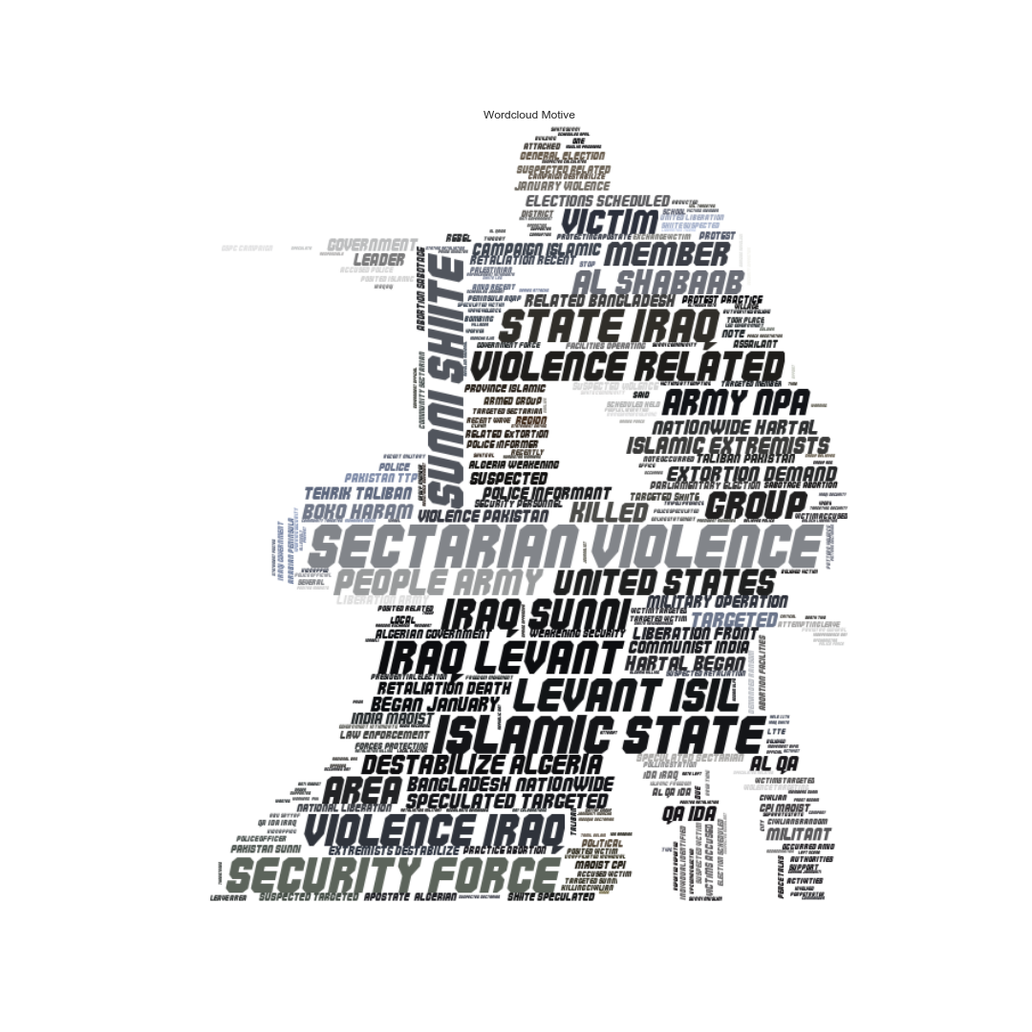

Conclusion:

The terrorism act has become international concern and want to try minimise the terrorism activities. There are so many innocents who have lost their lives and it is a heart breaking act of killing the innocents. Here we are trying to visualize the attacks that were carried out throughout the world and the effects of those attacks which leads to death, wounds and casualties caused due to the terrorist attacks. We have used Python and Bokeh to try visualize the terrorism data. The visualization helps in understanding the effects of terrorism activities such as death counts, wound counts, terror attack counts and casualties caused throughout the world due to the terrorism activities.

THANK YOU